Memory Forensics Analysis of KobayashiMaru.vmem
Ikemuefuna
Uzoh
Xeo102
University of Texas at San Antonio
July 10, 2026

Introduction
This report presents a memory forensics investigation of KobayashiMaru.vmem, a physical memory image from a Windows host in the SimSpace Win-Hunt lab environment. The analysis is performed using the process-oriented methodology described in the SANS memory forensics guidance, including identifying rogue processes, reviewing network artifacts, and checking for rootkit activity, utilizing the Volatility Framework, version 2.6 (Tilbury, n.d.). The results are presented question by question, with the supporting command output in the Appendix. All analysis was performed using Volatility 2.6, a standalone executable that is pre-installed on the assigned Win-Hunt virtual machine, executed against KobayashiMaru.vmem from the Windows Command Prompt. Volatility parses raw physical memory and reconstructs OS data structures – process lists, loaded modules, network state and registry hives – without booting or altering the captured system (Volatility Foundation, n.d.). The first step was to run imageinfo as its plugins need the correct OS profile and the profile it returned was supplied to every subsequent command with --profile (Tilbury, n.d.).

Question 3: Operating System and Version
imageinfo returned two candidate profiles, WinXPSP2x86 and WinXPSP3x86, and Volatility auto instantiated the image as WinXPSP2x86 (Figure 1), confirming a 32-bit Windows XP host running Service Pack 2 or 3. The "Image Type (Service Pack)" field returned 0, a minor inconsistency probably due to how that value is parsed from the kernel debugger block rather than a contradiction of the profile match; WinXPSP2x86 was used throughout. This host ( if it existed outside a lab ) would have been unpatched for years prior to the capture , which happened October 30, 2018, according to the image timestamp. Windows XP has been out of extended support since April 2014.

Question 4 and 5: RAM Allocated to the Analysis
The file properties for KobayashiMaru.vmem indicate a size of 512 MB (536,870,912 bytes, Figure 2). Because a .vmem file is a raw snapshot of a VM’s allocated physical memory, this size directly correlates to the RAM allocated to the source VM. This is confirmed by imageinfo stating "No PAE", which is correct for a 512MB Windows XP guest which does not need Physical Address Extension. The processes were listed with Pslist and Pstree (Figures 3-4). There was a baseline set of expected Windows XP and VMware guest-tools processes and they were unremarkable. These processes were: System, smss.exe, csrss.exe, winlogon.exe, services.exe, lsass.exe, explorer.exe, multiple svchost.exe, spoolsv.exe, logonui.exe, userinit.exe and the VMware tools. But this is not your average box by any means. A number of processes have no legitimate place on a standard workstation. hxdef100.exe (PID 1416) is a child of services.exe, is the known executable name of the Hacker Defender user-mode rootkit (Aldeid, n.d.). cryptcat.exe (PID 1472), an encrypted netcat variant, and bircd.exe (PID 1480), an IRC daemon/bot used as a backdoor and botnet control channel, are both directly spawned by hxdef100.exe. poisonivy.exe (PID 480), a child of explorer.exe, is the executable name of the well-documented PoisonIvy remote access trojan (FireEye, 2013). Three instances of iroffer.exe
(PIDs 1692, 1728, and 1824), an IRC bot that shares files using the "fserve" protocol commonly linked to pirated software distribution, are observed to be nesting with no normal parent process. cmd.exe (PID 560), winvnc4.exe (PID 548, a VNC remote-desktop server providing full remote control) and nc.exe (PID 532, netcat, a common attacker tool for remote shells and data transfer) all have a common parent PID 508, but no process with that PID is visible in pslist or pstree - consistent with a hidden or unlinked parent process, a technique associated with the Hacker Defender rootkit independently identified on this system (Question 8). pslist shows two of the three instances of iroffer.exe (PID's 1692, 1824) with almost identical start and exit times, meaning that they were executed for very short time, while PID 1728 was still running. The flagged processes all started within a minute or so of each other (20:46:3620:46:47 UTC, October 30, 2018), indicating a single coordinated toolkit deployment rather than a gradual, unrelated infection.

Question 6: User Account Names and Passwords
Credential recovery typically needs to find the SYSTEM and SAM hives and pass their offsets to hashdump (Tilbury, n.d.). The OS’s live hive list was walked by hivelist, which returned zero results (Figure 5). Hivescan, directly scanning memory pools, found twelve candidate offsets. However, hivedump against each of those only produced an empty header, with no key data (Figure 6). This pattern is repeated elsewhere in this analysis, where live-list plugins return empty while pool scanners partially succeed, suggesting the SYSTEM/SAM structures have been unlinked, moved or obscured - perhaps by the Hacker Defender rootkit, which has been known to hide registry keys as well as files, processes and ports (F-Secure, n.d.). No credentials could be retrieved. Even if you manage to get a successful hashdump, you will only get LM/NTLM hashes not the plaintext passwords because Windows XP's SAM never stores passwords in a recoverable plaintext format Windows XP's SAM never stores passwords in recoverable plaintext form.

Question 7: Dynamically Linked Libraries (DLLs)
dlllist was run on each suspicious process. The abnormality here is not so much in any one malicious DLL, but in what each DLL set and command-line path reveals. poisonivy.exe (PID 480) reported path C:\WINDOWS\System32\poisonivy.exe (Figure 7), loaded full networking stack (ws2_32.dll, WS2HELP.dll, mswsock.dll, wshtcpip.dll, rasadhlp.dll) with standard system DLLs, consistent with a process that actively opens outbound sockets, matching the live connection found under this PID in Question 8. hxdef100.exe (PID 1416) loaded only standard system libraries (Figure 8), which is expected: Instead, Hacker Defender hides itself via a kernel-mode driver and API hooking (F-Secure, n.d.). cryptcat.exe (PID 1472) loaded a far more extensive set, including directory/authentication libraries (SAMLIB.dll, ACTIVEDS.dll, NETAPI32.dll, WLDAP32.dll) and remote-access libraries (RASAPI32.dll, TAPI32.dll) - more than a simple encrypted netcat clone would normally require. bircd.exe (PID 1480) has reported its path as C:\hidden\bewareircd-win32\bircd.exe (Figure 9) with an unremarkable DLL set consistent with a locally hosted IRC server.

Question 8: Associating Processes, DLLs, and Executables
connscan scans memory pools for TCP endpoint objects, rather than the live connection table
(which itself was empty). It recovered three connections (Figure 11). PIDs 1728 (iroffer.exe) and 1480 (bircd.exe) were at opposite ends of a loopback connection on port 6667, confirming that bircd.exe hosts a local IRC service that iroffer.exe connects to. PID 480 (poisonivy.exe) had an outbound connection to 192.168.5.98:3460, consistent with PoisonIvy’s role as a remote access trojan checking in with a command-and-control server (FireEye, 2013) and linking PID 480, its
System32 executable path, and its networking DLLs to a live C2 channel.
PID 1416 and PID 1472 both resolve to executables in C:\hxdefrootkit\ (hxdef100.exe and cryptcat.exe), showing they were deployed together. PID 1480 resolves to
C:\hidden\bewareircd-win32\bircd.exe. PID 532 (nc.exe) and PID 548 (winvnc4.exe), not directly reachable via filescan, were resolved through their dlllist command-line fields to
C:\inetpub\ftproot\nc.exe and C:\inetpub\ftproot\VNC4\winvnc4.exe respectively (Figures 1314), discussed further below.

Question 9: Files Associated with the Processes
Multiple recovered file paths are abnormal and indicate the concealment strategy used and the likely entry point. poisonivy.exe is running from C:\WINDOWS\System32\poisonivy.exe – a classic “blend in” technique, as one more file in a sea of thousands in System32 is easy to overlook. Alternatively, hxdef100.exe and cryptcat.exe were stored in a separate directory in C:\hxdefrootkit\. Bircd.exe and iroffer.exe were placed in C:\hidden\bewareircd-win32\ and C:\hidden\ir\ respectively (Figure 12) – the inverse strategy, relying on Hacker Defender’s rootkit functionality to actively conceal these non-default directories from directory listings (Aldeid, n.d.). The key finding here is that both nc.exe and winvnc4.exe were staged under C:\inetpub\ ftproot\, which is the default FTP publishing root for Internet Information Services (IIS) - a service that was verified to be running on this host through inetinfo.exe (Question 5). The fact that attacker tools were found directly in the live, network-reachable FTP root suggests that these were the first artifacts to be uploaded, most likely via a vulnerable or misconfigured IIS/FTP service that was used as the entry point. The writable FTP root provided a convenient staging area before the rest of the toolkit was deployed.

Question 10: Analysis and Conclusion
This evidence taken together indicates a consistent compromise of an unpatched Windows XP host running IIS with an exposed FTP service. The attacker probably initially accessed the system via a vulnerability in the FTP service - nc.exe and winvnc4.exe, the most exposed tools, were staged right in the writable, network-reachable FTP root, a placement that only makes sense if that was the entry point. IIS FTP services in the Windows XP era had several publicly known unauthenticated vulnerabilities and this was a well-precedented attack path.
From there the attacker used netcat and/or VNC to get a shell or remote-desktop session, and unleashed a bigger toolkit: the Hacker Defender rootkit and cryptcat, installed to C:\ hxdefrootkit\; and an IRC daemon (bircd.exe) with a DCC file-serving bot (iroffer.exe), installed to C:\hidden\. All of these processes started within about a minute of each other, indicating a single scripted or manual deployment, rather than a gradual accumulation of separate infections. Once installed, it appears that Hacker Defender's rootkit driver interfered with a number of Volatility plugins that rely on walking live, OS-maintained lists: pslist showed three processes reporting a parent PID that was not in the list at all, hivelist returned no hives despite twelve being recoverable via hivescan, and connections returned no results despite three being recoverable via connscan. This live-list-empty, pool-scan-partial pattern is exactly what one would expect from a rootkit that hooks and filters the API functions used by standard enumeration tools (F-Secure, n.d.). Further maintaining access, the attacker also repurposed the host: bircd.exe and iroffer.exe running on port 6667 form a classic “IRC fserve” configuration historically used to distribute pirated software or media via DCC file transfer, meaning this box was actively serving as unauthorized distribution infrastructure. poisonivy.exe - buried in plain sight separately System32 - had an active outbound connection to 192.168.5.98:3460, consistent with an active
PoisonIvy command-and-control session (FireEye, 2013).
This pattern—an unpatched, network-facing Windows XP/IIS host that is exploited and turned into a rootkit-concealed IRC file server with a RAT layered on top—mirrors a well-documented category of mid-to-late-2000s incidents, an era when Hacker Defender was reportedly the most widely deployed rootkit in the world and was frequently paired with IRC bots like bircd and iroffer to build so-called “warez” boxes out of compromised servers (F-Secure, n.d.). The presence of PoisonIvy elevates this from basic piracy hosting as the RAT has a history of success in large, targeted intrusions like the compromise of RSA’s SecurID infrastructure in 2011 (PoisonIvy, n.d.). Whether this image represents one coherent incident or was put together to exhibit several malware families for training purposes, every artifact recovered – the rootkit, the covert-channel tool, the RAT, and the IRC file server, all staged through an exploitable IIS/FTP entry point – is in itself well-documented and consistent with real-world attacker tradecraft from this period of Windows XP compromise.

References
Aldeid. (n.d.). Hacker-Defender-hxdef. Retrieved July 10, 2026, from https://www.aldeid.com/wiki/Hacker-Defender-hxdef
F-Secure. (n.d.). Rootkit: W32/HacDef. F-Secure Labs. Retrieved July 10, 2026, from https://www.f-secure.com/v-descs/rootkit-w32-hacdef.shtml
FireEye. (2013). Poison Ivy: Assessing damage and extracting intelligence [PDF]. FireEye Inc.
PoisonIvy. (n.d.). In Wikipedia. Retrieved July 10, 2026, from https://en.wikipedia.org/wiki/PoisonIvy
Tilbury, C. (n.d.). Memory forensics cheat sheet (v1.2) [PDF]. SANS Institute.
Volatility Foundation. (n.d.). Volatility Framework — Volatile memory extraction utility framework. Retrieved July 10, 2026, from https://www.volatilityfoundation.org/

Appendix: Supporting Screenshots
The figures referenced throughout this report are reproduced below in full for reference.

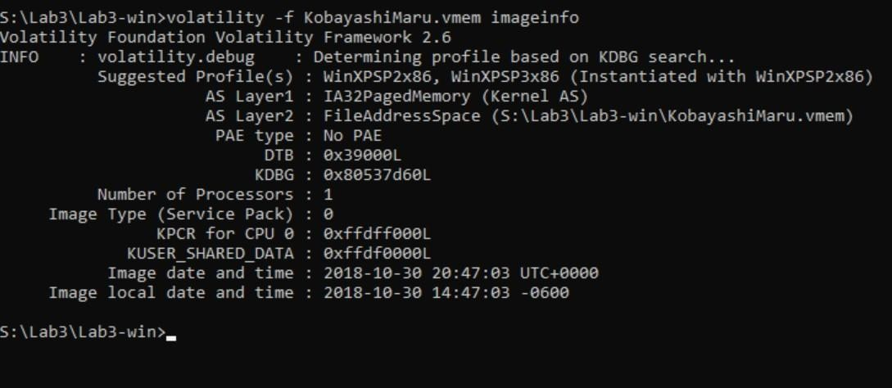
Figure 1. Output of "volatility -f KobayashiMaru.vmem imageinfo" showing the suggested profile, physical address space layout, and image capture timestamp.

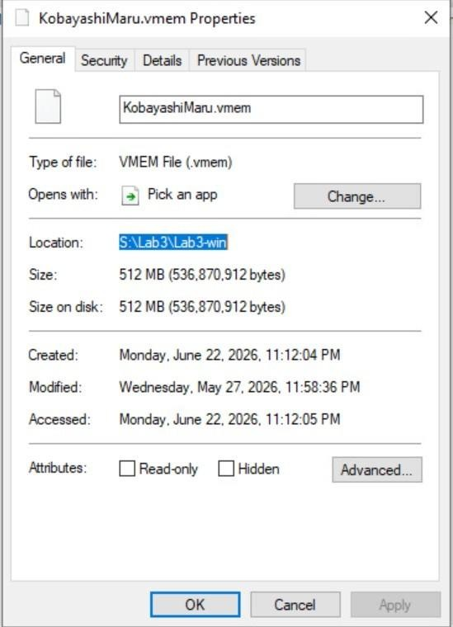
Figure 2. File properties for KobayashiMaru.vmem confirming a 512 MB memory capture.
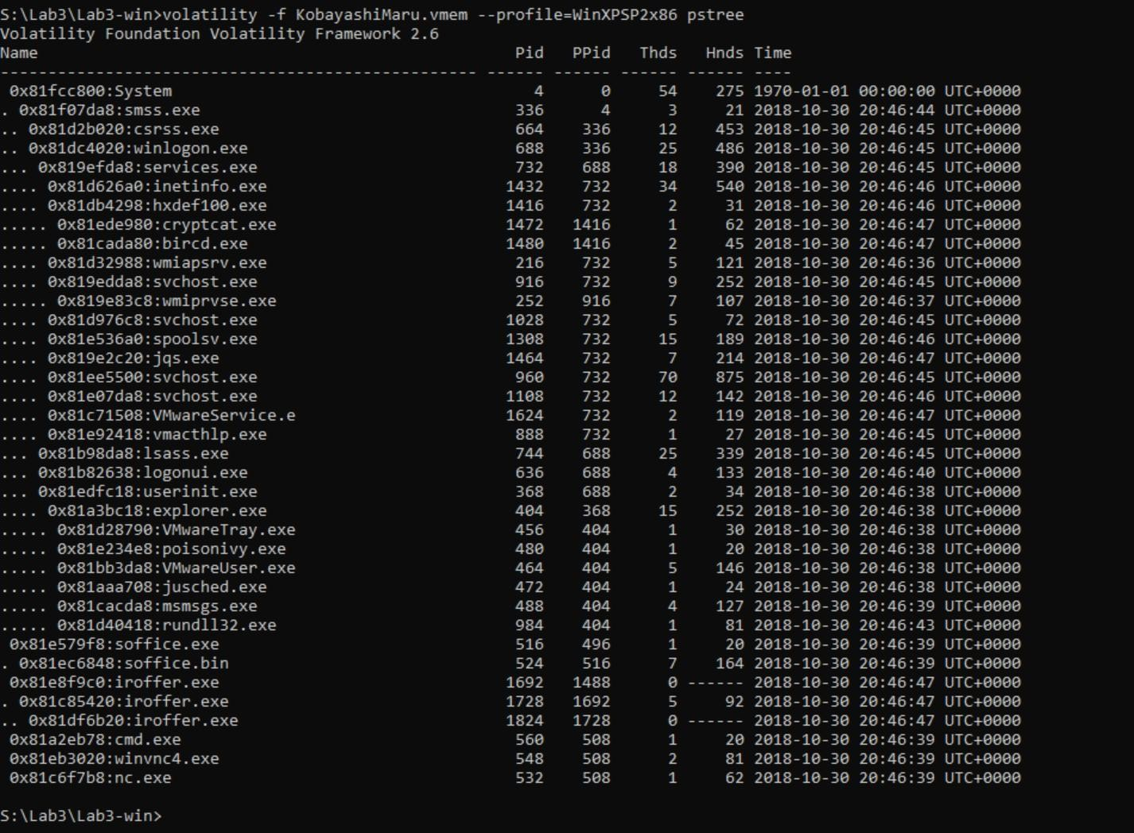
Figure 3. Output of the pstree plugin, showing process parent-child relationships.

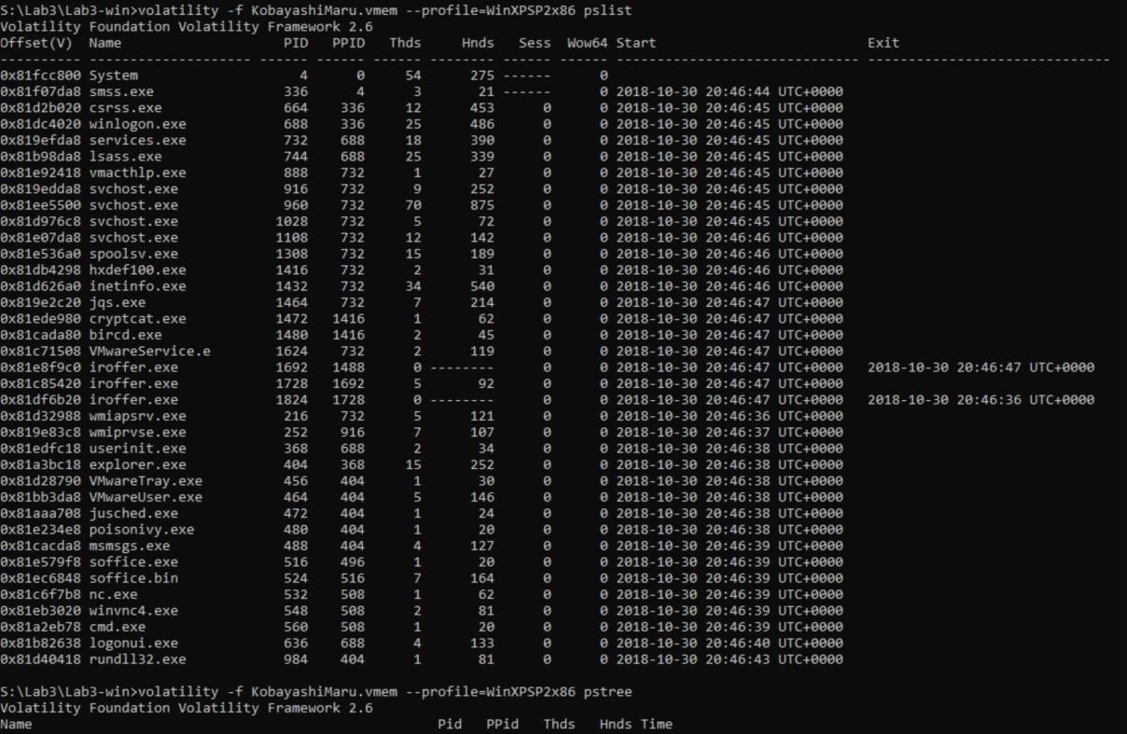
Figure 4. Output of the pslist plugin, showing PID, PPID, thread/handle counts, and process start/exit times.

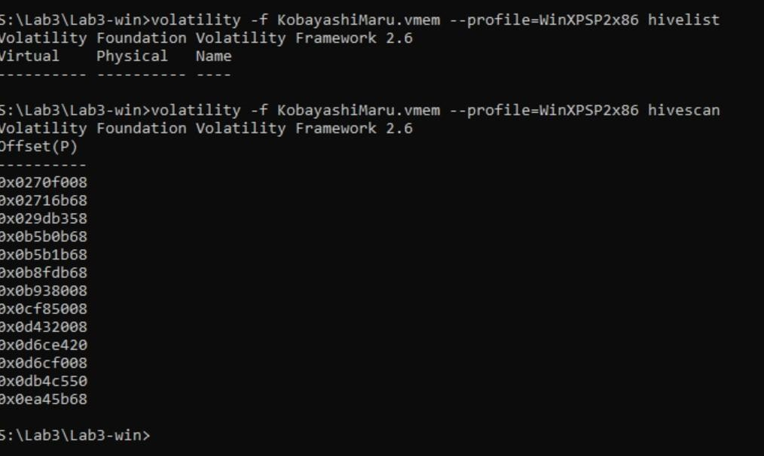
Figure 5. hivelist returning no results, contrasted with hivescan locating twelve raw hive offsets.
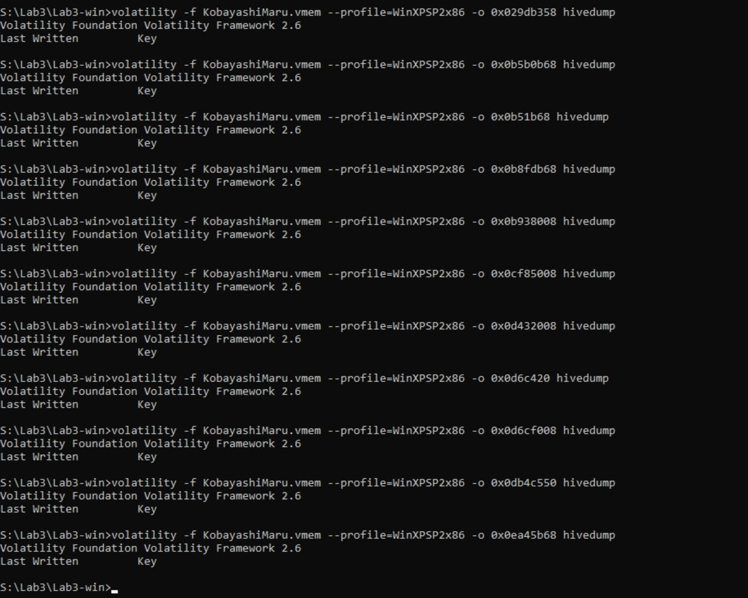
Figure 6. hivedump run against each of the twelve offsets identified by hivescan, each returning only the header row with no hive data.

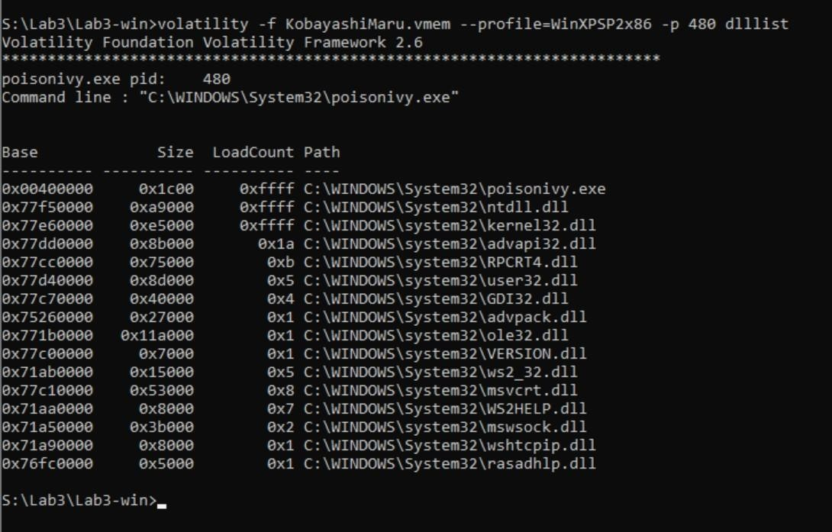
Figure 7. dlllist output for poisonivy.exe (PID 480), showing its System32 command-line path and loaded networking DLLs.
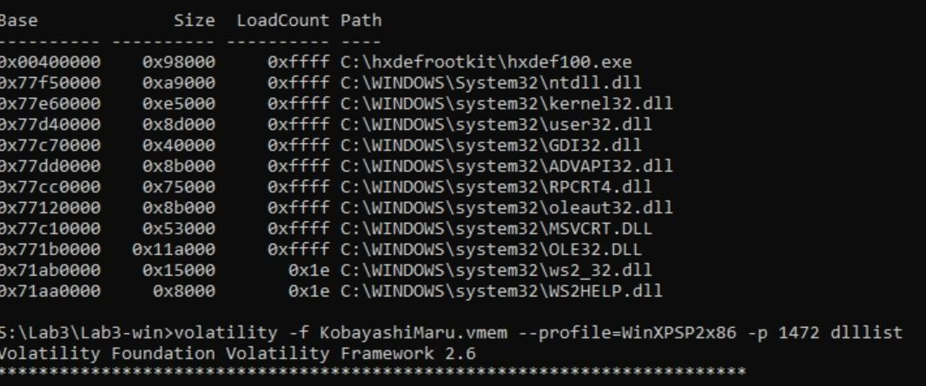
Figure 8. dlllist output for hxdef100.exe (PID 1416) and the beginning of the cryptcat.exe (PID 1472) listing.

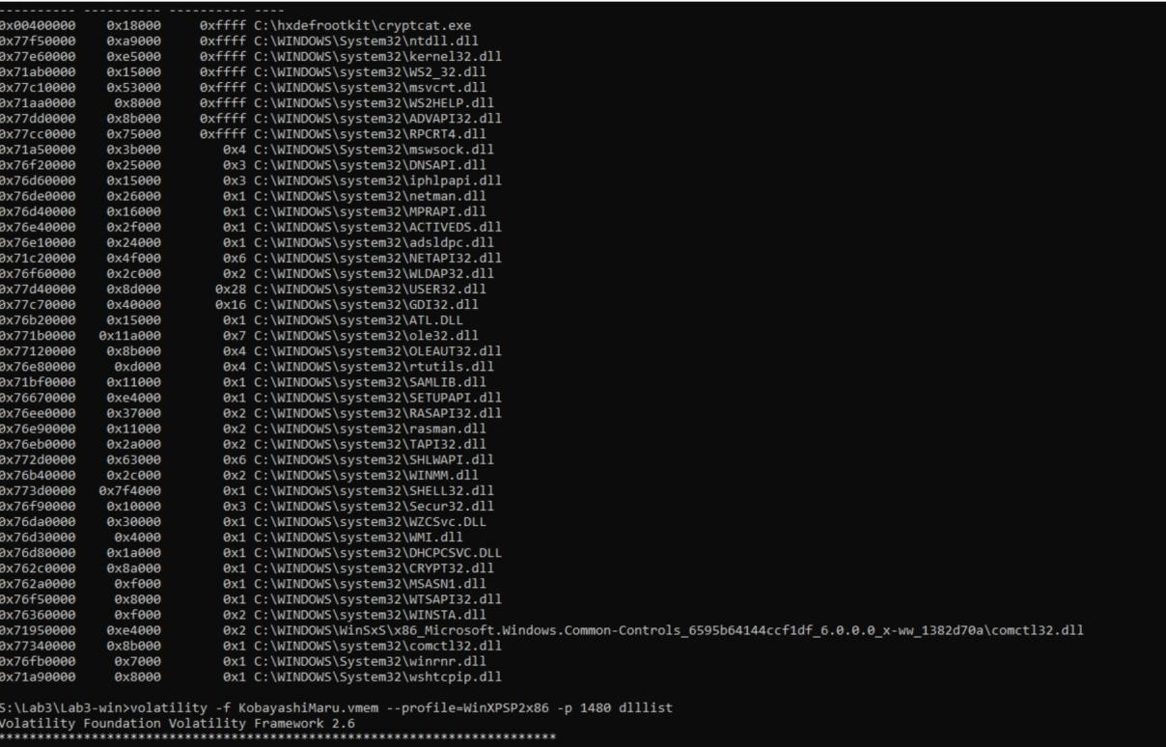
Figure 9. Full dlllist output for cryptcat.exe (PID 1472), including its broader-than-expected DLL set.
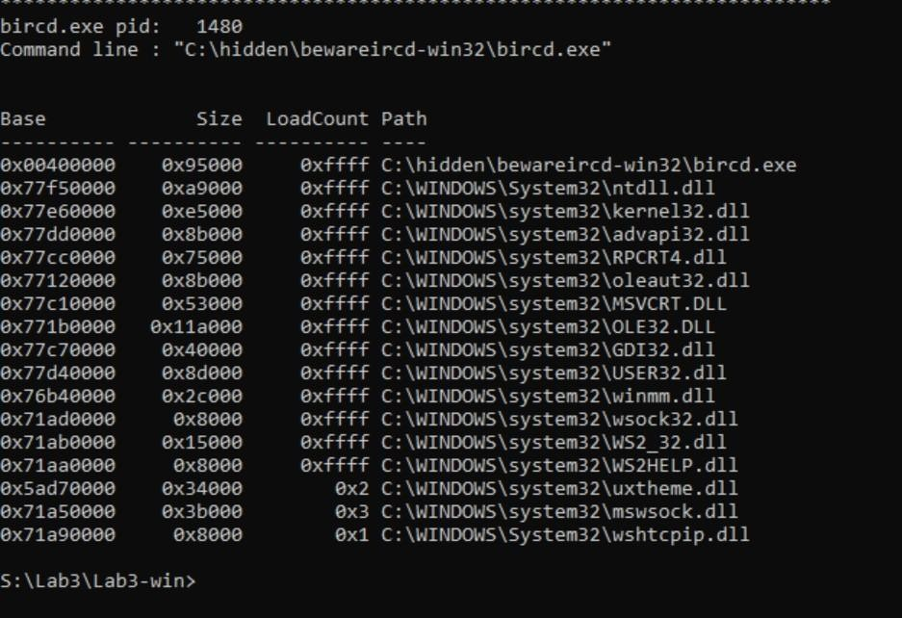
Figure 10. dlllist output for bircd.exe (PID 1480), showing its command-line path in the C:\hidden\ directory.

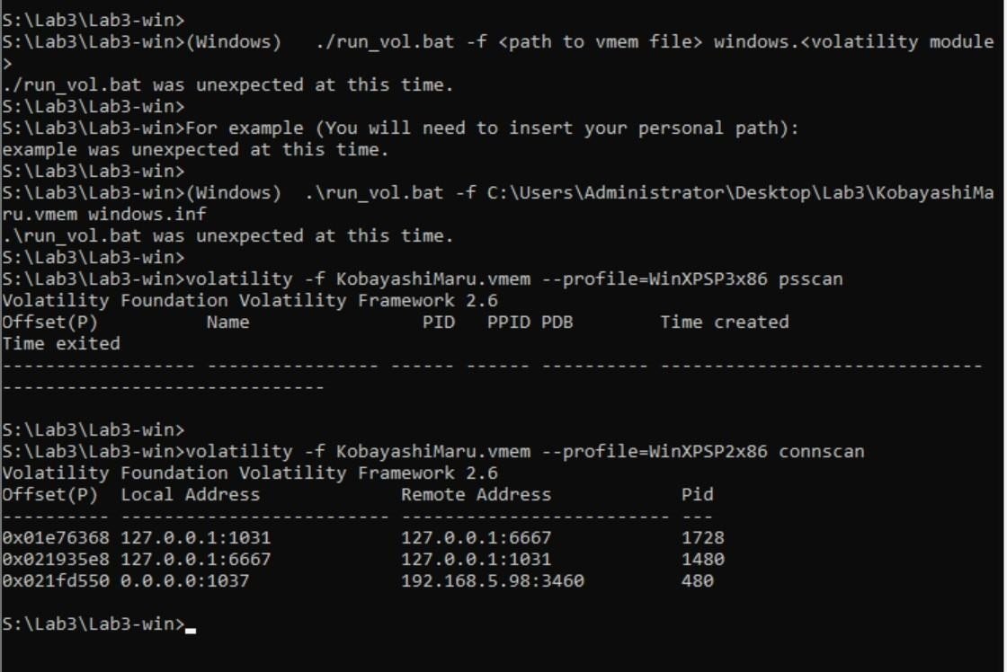
Figure 11. connscan output identifying the loopback IRC connection between iroffer.exe and bircd.exe, and the outbound connection from poisonivy.exe to 192.168.5.98:3460.
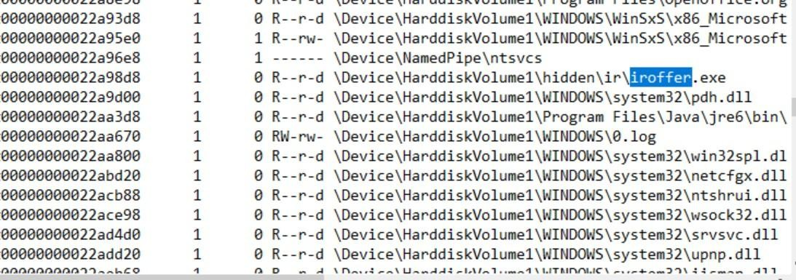
Figure 12. filescan output locating iroffer.exe at \Device\HarddiskVolume1\hidden\ir\iroffer.exe.

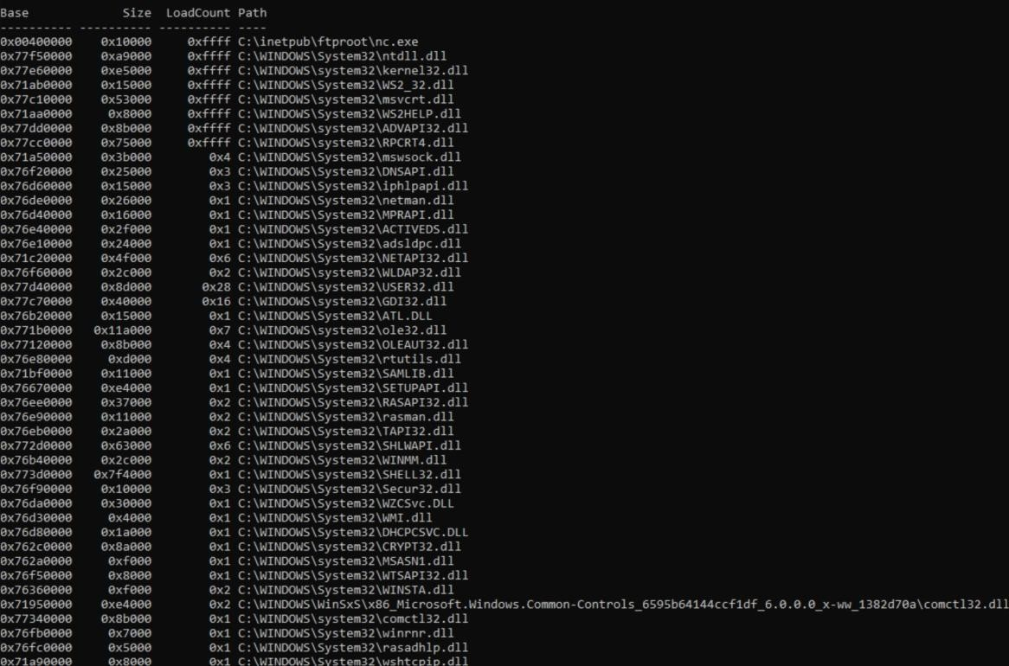
Figure 13. dlllist output for nc.exe (PID 532), showing its path inside the IIS FTP root directory.
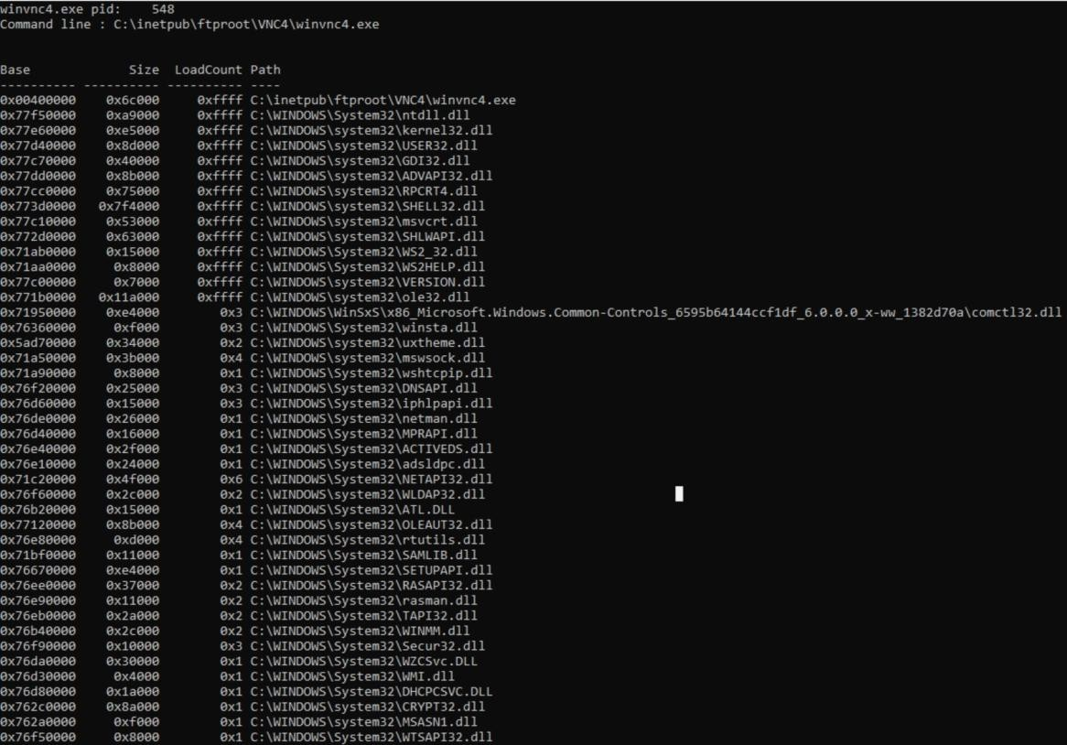
Figure 14. dlllist output for winvnc4.exe (PID 548), showing its path inside the IIS FTP root directory.

